**JAYPEE UNIVERSITY OF INFORMATION TECHNOLOGY**

**WAKNAGHAT**

**Operating Systems Lab**

**Lab Assignment dated 31.01.2022**

**Name -** Akash Kumar Singh

**Roll no -** 201460

**Batch -** CS 48

**Task 1: WAP to show the execution of child process before parent process using wait( ) system call.**

#include<stdio.h>

int main()

{

printf("OS Lab!\n");

int rval=fork();

if(rval==0)

{

printf("We are using wait() system call\n");

printf("I am child process with PID %d.\n",getpid());

}

else

{

wait(NULL);

printf("We are using wait() system call\n");

printf("I am parent process with PID %d.\n",getpid());

}

return 0;

}

**//Output –**

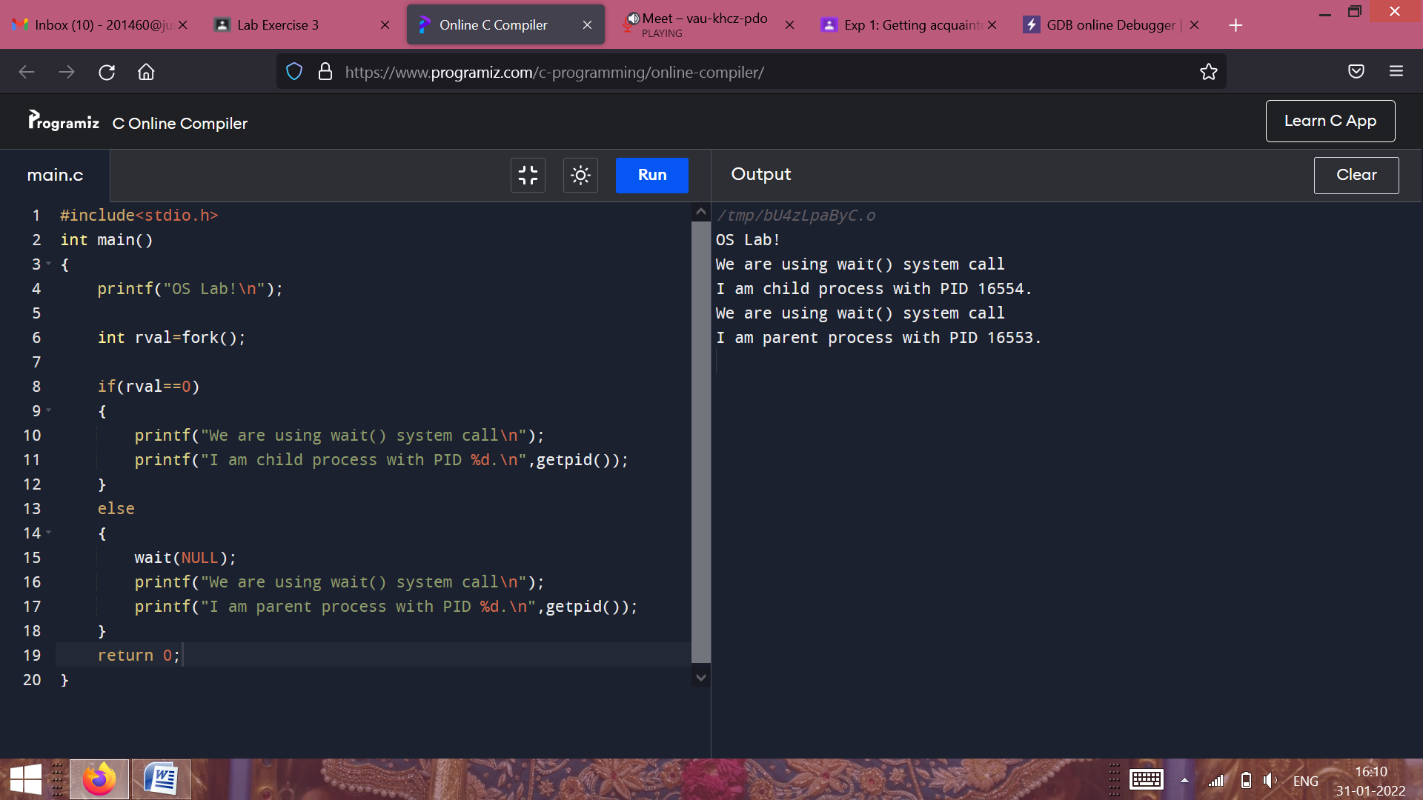

**Task 2: WAP to show the execution of parent process before child process using sleep( ) system call.**

#include<stdio.h>

int main()

{

printf("OS Lab!\n");

int rval=fork();

if(rval==0)

{

sleep(5);

printf("We are using sleep() system call\n");

printf("I am child process with PID %d.\n",getpid());

}

else

{

printf("We are using sleep() system call\n");

printf("I am parent process with PID %d.\n",getpid());

}

return 0;

}

**//Output –**

